PART B
(PART B: TO BE COMPLETED BY STUDENTS)
Roll No: B032 | Name: Naman Garg
Class: BTech CS-B | Batch: B2
Date of Experiment: | Date of Submission:
Grade

B.1 Work done by student
- Prepare working environment for the Lab and load data files
- Set the working directory to LAB01 where we have stored the data. On the console window type:
setwd("~/LAB01")

- In the script window, open the script called “Module3Lab2.R”. (Click on “File”, “Open File” and Navigate to directory LAB03 and click on file “Module3Lab2.R”).
Start R and Read the Data Set Back Into Your Workspace:

- Execute the following commands from the script window:
ls()
load(file=”Labs.Rdata”)
ls()
rm(lab2)
ds <- lab1
colnames(ds) <- c("income", "rooms")

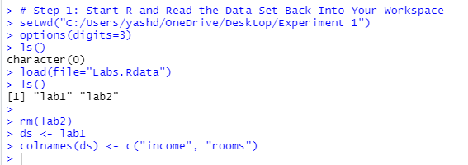

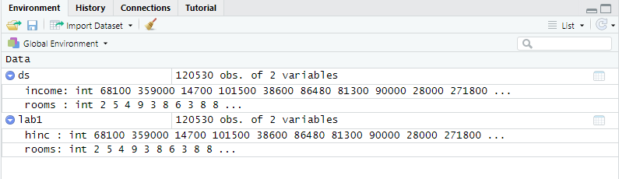

- Obtain summary statistics for Household Income and visualize data:
- Execute the following commands from the script window:
summary(ds$income)
range(ds$income)
sd(ds$income)
var(ds$income)
plot(density(ds$income)) # left skewed

- What is the mean? 67152
- What is the median? 50300
- What is the standard deviation? 68178 .
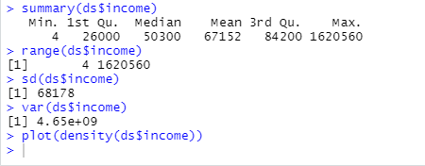

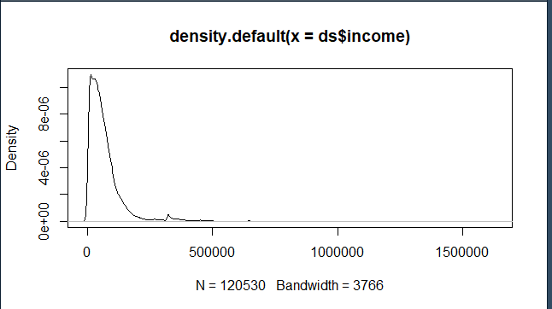

- Obtain summary statistics for Number of rooms and visualize data:
- Execute the following commands from the script window:
summary(ds$rooms)
range(ds$rooms)
sd(ds$rooms)
plot(as.factor(ds$rooms))

- What is the mean? 5.63
- What is the median? 6.0
- What is the standard deviation? 1.99

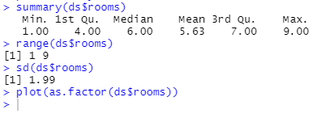

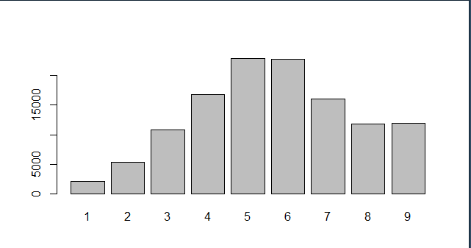

- Remove Outliers
In a previous lab, you recorded the range of income. You observed that the minimum household income is 4, and the maximum is 1,620,560.

- Does this make sense to you? Why?
Ans: Yes, as it suggests the big difference in the max and min indicating a very large range of income values. They can prove to be the outliers.

- What happens if you throw out the top and bottom 10%? Execute the following line from the script window
Ans: (m <- mean(ds$income, trim=0.10) )

This causes the reduction in the range of income values as it reduces the top 10% and bottom 10% of the income values thus removing the outliers.

- How does this compare to the previous mean of this variable?
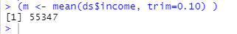

As we can see, the mean value has reduced.This can be because we have removed some of the very large values while trimming which was causing the mean to be higher.

- Execute the following commands from the script window:
ds <- subset(ds, ds$income >= 10000 & ds$income < 1000000)
summary(ds)
quantile(ds$income, seq(from=0, to=1, length=11))

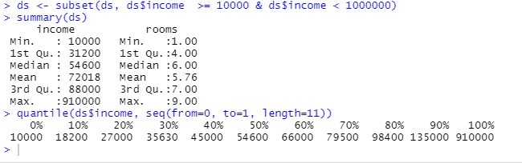

- How do these values vary from the values in the original data set?
Ans: These values are filtered i.e. using the subset() function we have only taken values that satisfy a condition. These values are less skewed now.
- Do they make more sense?
Ans: Yes, some outliers are removed resulting in a normalized and less skewed data.
- Which data set would you prefer to use?
Ans: A clean data which is normalized so that any data mining algorithm will give high accuracy and less loss.
We might consider the high and low value as outliers, and get rid of them. On the other hand, as we will discover, income is best described via a lognormal distribution, and hence these values are in the extreme ends +- 3 sds from the mean.

- Stratify Variable – Household Income and plot the results:

Stratify breaks that occur close to U.S. Guidelines for Poverty, Median Income, Wealth, and Rich (> $250k @ year)

- Execute the following code (listed under comment heading “step 5” in the script file):
breaks <- c(0, 23000, 52000, 82000, 250000, 999999)
labels <- c("Poverty", "LowerMid", "UpperMid", "Wealthy", "Rich")
wealth <- cut(ds$income, breaks, labels)
# add wealth as a column to ds
ds <- cbind(ds, wealth)
# show the 1st few lines.
head(ds)

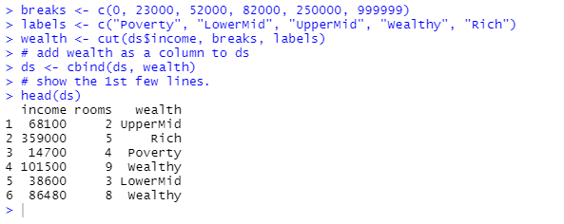

- Continue to execute the remaining part of the code in Step 5
wt <- table(wealth)
percent <- wt/sum(wt)*100
wt <- rbind(wt, percent)
wt
plot(wt)

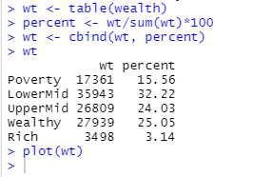

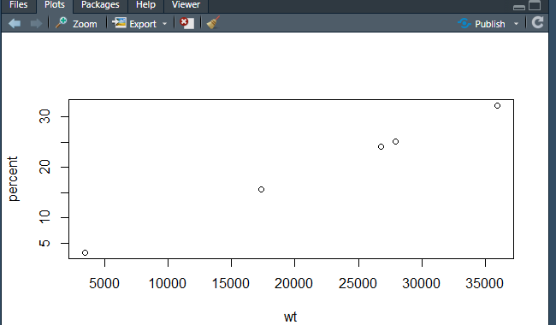
- Take another look at the relationship between wealth and income. Execute the following lines:
# take another look -- wealth by rooms
nt <- table(wealth, ds$rooms)
print(nt)
plot(nt) # nice mosaic plot

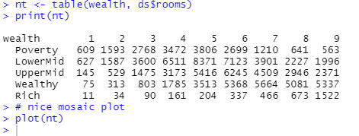
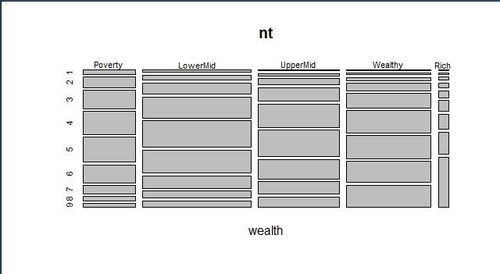
- Execute this code from the script file. These lines will remove the variables wealth, breaks and labels, and then save the variables data set and write into a file named “Census.Rdata”.
rm(wealth,breaks,labels)
save(ds, wt, nt, file="Census.Rdata")

- Plot Histogram and Distributions:
Problem: How do you represent income given the range of values?
1. Select and execute the code under Step 6 Histograms and distributions in the script file.
library(MASS)

with(ds, {
hist(income, main="Distribution of Household Income", freq=FALSE) lines(density(income), lty=2, lwd=2)
# line type (lty) 2 is dashed
xvals = seq(from=min(income), to=max(income), length=100)
param = fitdistr(income, "lognormal")
lines(xvals, dlnorm(xvals, meanlog = param$estimate[1], sdlog = param$estimate[2]), col =”blue”)
})

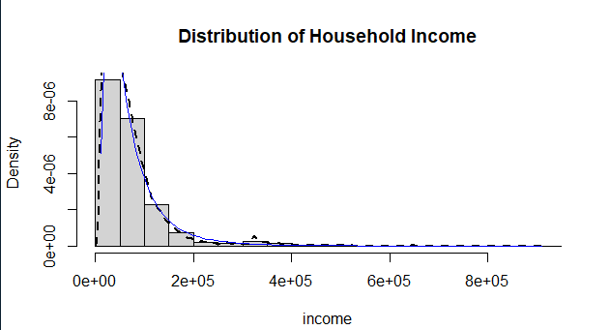

2. Now try the same thing with log10(income)
logincome = log10(ds$income)
hist(logincome, main="Distribution of Household Income", freq=FALSE)
# line type lty(2) is a dashed line
lines(density(logincome), lty=2, lwd=2)
xvals = seq(from=min(logincome), to=max(logincome), length=100)
param = fitdistr(logincome, "normal")
lines(xvals, dnorm(xvals, param$estimate[1], param$estimate[2]), lwd=2, col=”blue”)

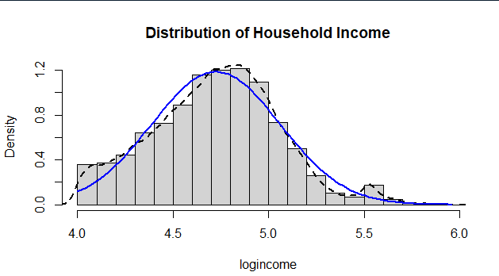
- Compute Correlation between income and number of rooms:
1. You need to consider your hypothesis.
- Your hypothesis is that the number of rooms in a house is predicted by household income (the rich can buy bigger houses), e.g. lm(rooms ~ income)
- Therefore, our null hypothesis: no correlation between income and number of rooms.
- Alternate hypothesis: there is a correlation between income and the number of rooms.
- Execute the following code (listed after the comment line “Step7 in the script file).
with(ds, cor(income, rooms))
with(ds, cor(log(income), rooms))) # this will give a better correlation

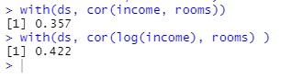
- For comparison, correlate rooms with a completely unrelated variable.
n = length(ds$income)
with(ds, cor(runif(n), rooms))

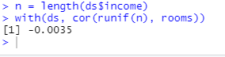

- Create a Boxplot - Distribution of income as a factor of number of rooms:
- Select and execute the code (Listed after the comment line “Step 8”) in the script window.
- Plot the distribution of income as a factor of # of rooms. ‘log=”y”’ plots income on log scale. We will suppress the outlier points and let the whiskers cover the full range of the data.
boxplot(income ~ as.factor(rooms), data=ds, range=0, outline=F, log=”y”, xlab="# rooms", ylab="Income")
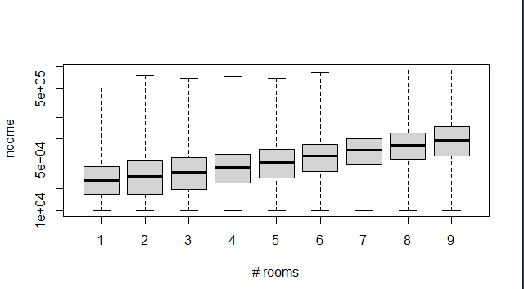

- Plot the # of rooms as a function of wealth level.
boxplot(rooms ~ wealth, data = ds, main="Room by Wealth", Xlab="Category", ylab="# rooms")

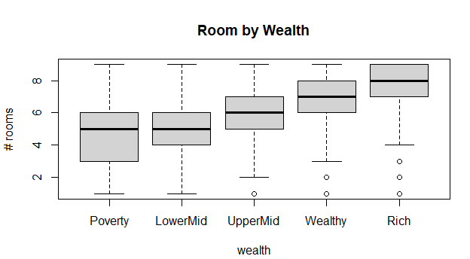

B.2 Conclusion
(Students must write the conclusion as per understanding of individuals after completing this practical.)
I understood how to handle skewed data by trimming the outliers or by selecting only a subset of the data where we can see that it is normalized.
I learnt how to assign numbers a particular category using cut() based on the breakpoints.
I also learnt to plot different types of graphs including histogram, box plot, line graph etc.
Lab 2 Exercise:

Q.1 a) Create a dataframe named emp_data which contains employee information.
Emp_data has attributes: emp_id, emp_name, salary, start_date.
emp_data=data.frame(
emp_id=c(1:10),
emp_name=c('naman','manna','gaman','faman','raman','baman','laman','haman','kaman','vaman'),
salary=c(3000.0,22500.0,2500.0,2100.0,1900.0,1950.0,1952.0,1458.0,2036.0,2700.0),
start_date=as.Date(c("2013-02-11", "2016-06-22", "2020-10-05", "2017-07-11",
"2014-04-17","2020-07-18", "2018-09-10", "2019-09-18", "2015-01-05",
"2015-06-20")),
stringsAsFactors = FALSE

)
print(emp_data)

print(str(emp_data))

summary(emp_data)

res<-emp_data[1:2,]
res

res2<-emp_data[c(3,5),c(2,4)]
res2
b) Insert data for 10 objects in dataframe. Start_date column should contain date in yyyy-mm-dd format.

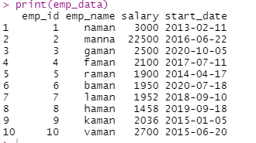

c) Display the structure of dataframe.(search appropriate command for this).

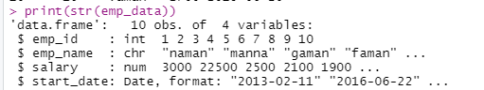

d) Display 5 point summary of dataframe. What is your observation for ‘emp_name’ attribute?

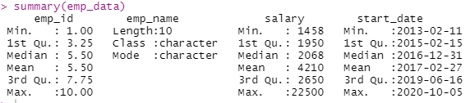

e) Display exactly first 2 rows of dataframe

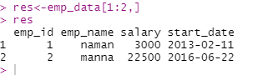

f) Extract 3rd and 5th row with 2nd & 4th column.and display

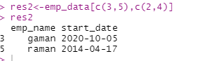

Load dataset from packages and perform EDA

Q.2 Read the following carefully
Packages in R:
# R packages are a collection of R # functions, complied code and sample data.
# They are stored under a directory called "library" in the R environment.
# By default, R installs a set of packages during installation. More packages are added later,
# when they are needed for some specific purpose
# After installing package also have # to load it in workspace using library('packagename')

# E.g : Install package "XML".
install.packages("XML")
# Loading the package
library('XML')

R has built in datasets in ‘datasets’ package.
‘mtcars’ is one of the dataset.
Load this dataset and Do following activities:
- Display column names in ‘mtcars’
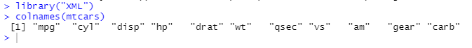

- Display five point summary of dataframe

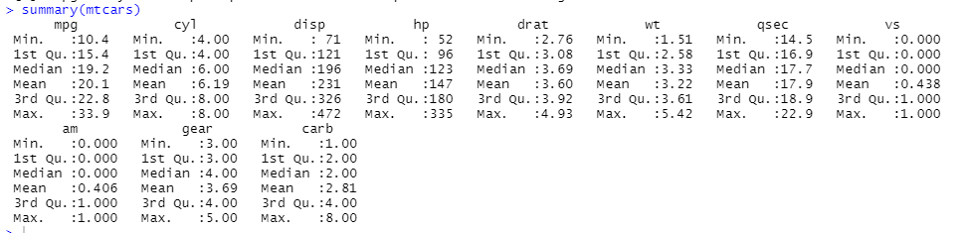

- Draw the boxplot for individual attribute in mtcars

